**Factor Allocation for Indian Equities**

We focus on allocation to the four factors in Cahart’s four factor model – market, size, quality and momentum.

For this, we will study how all of these factors perform in different macro-economic conditions and create rules to allocate optimally to each factor.

1. **Market**: The market factor aims to mirror the broader market performance, and what impacts their performance in different market conditions.
2. **Size**: It is a well-known fact that a portfolio of small companies tends to outperform a portfolio of large companies for a long investment horizon.
3. **High Book to Market:** Companies with High book value to market cap ratios tend to outperform
4. **Momentum**: Momentum is essentially the idea that a stock that has performed well in the recent past will keep performing well.

**Interest Rates, Inflation, and Factor Returns for India - 2005 to 2024**

Monetary policy is one of the most crucial factors that affects stock returns for any country. Historically, India's central brank, the Reserve Bank of India (RBI) has been rather conservative with monetary policy and averse to making any major changes. Even during the financial crisis of 2008, it kept the interest rates unchanged and let things follow their natural course. In this article, I've explored the history of interest rates and inflation, and tried to understand their effect on stock returns and factor returns from 2005 to 2024.

**Brief History of Monetary Policy in India**

* Two major developments in the last 20 years made the central bank a little more pro-active. First was the rising inflation in 2011, and second was the Covid 19 pandemic in 2020. Let's look at the events in chronological order to make sense of them.
* From 2003 to 2011 the interest rate stayed constant at 6%. Inflation (measured by the change in consumer price index) rose steadily for three years from 2008, eventually peaking at 12% at the end of 2010. It dipped slightly in 2011, but remained high at the end of 2011. This was a period of high inflationary growth.

**Figure 1: Annual Inflation in India based on CPI (2004 to 2023)**

* In 2012, the RBI increased interest rates to combat inflation. It was hiked to 9% from 6%, and from 2012 to 2014 it hovered close to 9%. It worked, and by the end 2015, inflation was back under 5%.
* The subsequent years saw a gradual easing of interest rates as they hovered around 6% while inflation stayed moderated at close to 4%. 2014 to 2019 was again a period steady inflationary growth.
* In 2020, the pandemic hit, and the RBI cut interest rates to 4.25%. They kept it that way until May 2022. This led to a V-shaped recovery in the stock market, and a bull market from the end of 2020 to 2024.
* As you would expect, increasing money supply came at a cost - inflation was starting to creep back in. Although not drastically, it increased to 5-6% during 2022 to 2024.

**Current Situation (Dec 2024)**

As of Dec 2024, India is in a careful position where corporate earnings growth has slowed and inflation is at 5.48%, which is on the higher end of its inflation band of 2% to 6%. To give you an idea of the earnings growth slowdown, here are some statistics for the September 2024 quarter,:

* **4% YoY growth** for the NIFTY 50 companies
* The September quarter turned out to be the worst one since early 2020 for India, as at least 36 BSE 500 companies reporting over **50% plunge in their quarterly profit** on a year-on-year (YoY) basis
* Nifty earnings growth projections reduced to **5%** for FY25 from 7% by Motilal Oswal after discouraging September quarter results.

At this point, cutting interest rates could drive inflation further up, while not cutting them could lead to an extended period of slowdown. This should make investors cautious and re-think allocation to different factors.

**Different Interest Rates and Inflation Regimes**

I studied the history of interest rates, inflation and stock returns for India to understand how the markets performed during similar periods of rising inflation. I was able to get historical data from 2005 to 2024, and I split this period into 5 different 'regimes' of interest rates and inflation.

**Figure 2: Interest Rate v/s Quarterly Inflation (2004 to 2024)**

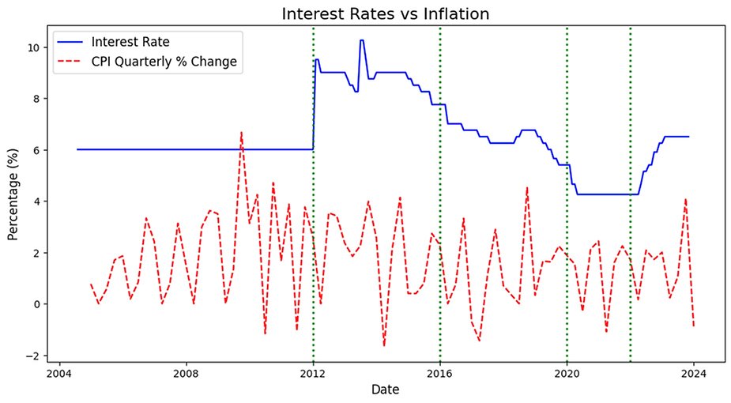

These periods are:

* 2005 to 2011: Moderate Interest Rates and Rising Inflation
* 2012 to 2016: High Interest Rates and Falling Inflation
* 2017 to 2019: Falling Interest Rates and Moderate Inflation
* 2020 to 2022: Low Interest Rates and Moderate Inflation
* 2023 to 2024: Moderate Interest Rates and Rising Inflation

The following plot shows the quarterly returns for the MSCI India index during this period.

**Figure 3: Interest Rates v/s MSCI India Index Quarterly Returns**

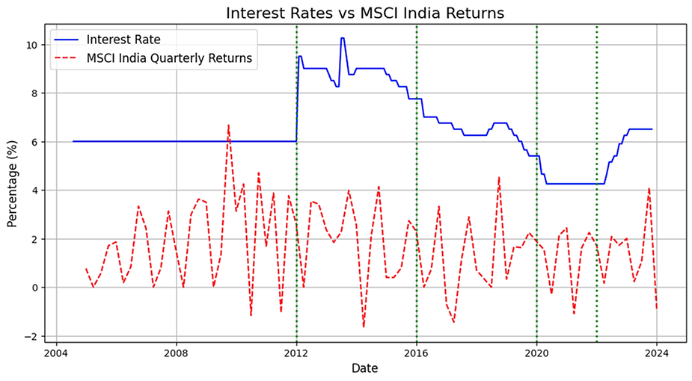

**Table 1: Interest Rates, Inflation and Stock Returns for the five periods**

|  |  |  |  |
| --- | --- | --- | --- |
| **Period** | **Average Interest Rate** | **Average Inflation Rate** | **Average Yearly Returns (MSCI India)** |
| 2005 to 2011 | 6% | 8.07% | 25.37% |
| 2012 to 2016 | 7.875% | 7.21% | 12.89% |
| 2017 to 2019 | 6.2875% | 3.56% | 13.95% |
| 2020 to 2022 | 5.0375% | 6.17% | 16.82% |
| 2023 to 2024 | 5.25% | 5.31% | 13.24% |

**Key Takeaways:**

* 2005 to 2011 was a period of high inflationary growth and high returns for stocks. By the end of this period inflation spiraled out of control and the RBI had to hike interest rate to bring it under control
* 2012 to 2016 saw the effect of higher interest rate reflected in moderate stock returns (lowest of all the periods in question). Inflation was reduced, but still stayed fairly high.
* 2017 to 2019 saw a gradual decrease in interest rates as inflation decreased significantly. Stock returns were slightly higher, but still quite modest.
* 2020 to 2022, saw the lowest interest rates and stock returns were fairly high. There was a V-shaped recovery from the covid 19 crash, and it was virtually just a blip in the larger picture.
* 2023 to 2024 saw moderately low interest rates and inflation started to creep back in. Stock returns reduced slightly.

**History of Factor Performance**

To understand how the different factors performed during market regimes defined by changing inflation conditions and interest rates.

**Table 2: Excess Factor Returns for Cahart 4-factor Model**

|  |  |  |  |  |
| --- | --- | --- | --- | --- |
| **Period** | **Market** | **Size** | **Book to Market** | **Momentum** |
| 2005 to 2011 | 25.36% | 2.52% | -2.61% | 3.84% |
| 2012 to 2016 | 5.79% | 1.19% | -5.59% | -4.94% |
| 2017 to 2019 | 11.21% | -9.98% | -11.51% | 17.03% |
| 2020 to 2022 | 9.23% | 9.60% | 2.51% | 2.63% |
| 2023 | 12.08% | 23.95% | 18.25% | 9.61% |

*Factor data for 2024 not available

There is a lot of research around factor returns in different market conditions, and it would be good to see if the findings hold true for the Indian market. First, we will look at factor performance over the entire period of 2004 to 2023. We want to understand two things:

1) The market beta of factors: This tells us if factor returns move in the same direction as market returns, and if so, how strongly.

2) Alpha for the factors: How much excess returns over the market benchmark do these factors produce on an annualized basis.

Blitz, David, The Cross-Section of Factor Returns (May 8, 2023). Available at SSRN: <https://ssrn.com/abstract=4441376>

* For the US market, Size has positive market beta, while Momentum and Book to Market have negative market betas. We can see that the Size and Momentum follow the same behavior, but Book to Market has a positive market beta. This is counter-intuitive because we expect value factors to do well when the broader market is not.

**Figure 4: Market Betas for Book to Market, Momentum and Size factors (2004 to 2023)**

* For the US market, all three factors have positive annualized alpha. We see that this is not the case for India. Only Momentum shows a positive annualized alpha.

**Figure 4: Annualized Alpha for Book to Market, Momentum and Size factors (2004 to 2023)**

Now let's look at the betas and alphas for different periods

**Period: 2005 to 2011 (Inflationary Growth)**

Book to Market and Size have a positive beta. Therefore, they don't make good diversifiers and don't produce excess returns either. In this period of inflationary growth and high stock market returns, only momentum has a positive alpha. **Momentum** can therefore be a good diversifier and also produce excess returns.

**Figure 5: Market Betas (2005 to 2011)**

**Figure 6: Alphas (2005 to 2011)**

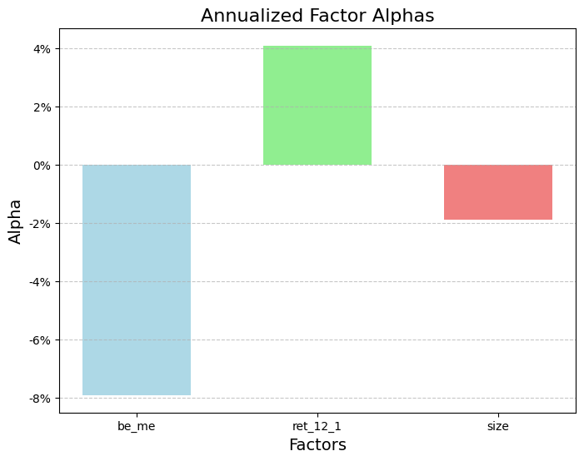

**Period: 2012 to 2016 (High Interest Rates, Decreasing Inflation)**

In this period of high interest rates and slow growth, betas for factors remain the same. But alphas are all negative. This means that it is difficult to find alpha when interest rates are high and the broader market returns are modest.

**Figure 7: Market Betas (2012 to 2016)**

**Figure 8: Alphas (2012 to 2016)**

**Period: 2017 to 2019 (Moderate Interest Rates, Low Inflation)**

The market beta for momentum reverses during this period. Although it loses its trait of a good diversifier, its alpha is much higher. Both size and book to market underperform during this period.

**Figure 9: Market Betas (2017 to 2019)**

**Figure 10: Alphas (2017 to 2019)**

**Period: 2020 to 2022 (Low Interest Rates, Increasing Inflation)**

This is another period of inflationary growth. As with the previous period of inflationary growth (2005 to 2011), momentum performs well and retains a negative beta. This is the first period where the size factor produces a positive alpha.

**Figure 11: Market Betas (2020 to 2022)**

**Figure 12: Alphas (2020 to 2022)**

**Period: 2023 (Increasing Interest Rates, Increasing Inflation)**

The momentum factor again reverses its beta, and loses its trait of a good diversifier. Size and Book to Market produce high alphas, while momentum still manages to produce a low positive alpha.

**Figure 13: Market Betas (2023)**

**Figure 14: Market Betas (2023)**

**Takeaways:**

* The **Book to Market** (value) factor strangely underperforms the market in most regimes and does not provide uncorrelated returns either. Therefore, it is neither a good diversifier, nor an alpha producing factor.
* **Momentum** has negative market beta during periods of inflationary growth and is most consistent in producing alpha as well. In periods of low inflation, its market beta turns positive, but it still generates alpha.
* **Size** always has a positive market beta, which means it only performs well during bull markets. It has only produced positive alpha since 2019, a period of lower inflation and moderate to low interest rates. This can indicate that small companies benefit the most from lower interest rates.